**The Hands-On Clinical Workshops**

**General Guidelines & Description**

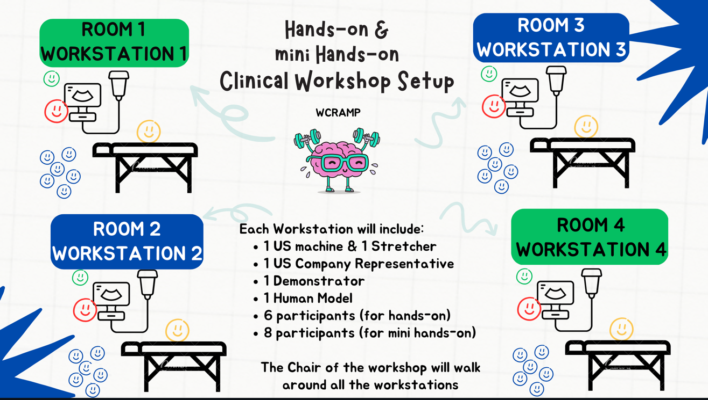

**All Hands-on Clinical Workshops will be held in the Congress Center**

**Definition:**

These clinical workshops simulate clinical OR (operation room) or ICU /Emergency

Scenarios, which serve as basis to teach the different ultrasound guided blocks to our delegates.

These workshops are **HANDS ON** with **ACTIVE** ultrasound scanning on models by the delegates. This definition is valid for all clinical workshops (adults, paediatrics, chronic pain and POCUS).

**Number of Workstations per Workshop:**

4 Workstations with different scenarios/topics.

One demonstrator with one US (ultrasound machine). One model per Workstation.

**Duration:**

2 hours, with 30 min approximately per workstation

**Ultrasound – workshop ratio:**

4 US with one model each per workshop (1 workshop covers 4 clinical scenarios/topics)

**Ultrasound – delegate ratio:**

1:6 = max 6 pax per workstation / ideal for a total of 24 delegates

**Instructors:**

There will be 1 instructor per workstation = 4 demonstrators per workshop

**Chairman – Workshop Leader:**

There will be one Chairman/Workshop Leader per workshop [usually **NOT** active (=teaching) involved in the assigned Workshop], But mainly involved in coordination a WS flow

**Note:**

For the MINI HANDS ON WS, there is only one demonstrator (instructor)

1 US Machine

No chair, An audience of up to 8 delegates for one hour training

**Material needed:**

* With every US there must be one male or female model!
* Complete US equipment (battery loaded, working connection for power supply)
* Enough gel for all workshops, appropriate towels to clean the US-probe
* One stretcher or other comfortable surface and pillows for positioning the models for a duration of up to 3 hours for scanning them in different positions.
* Enough towels and blankets to cover the models.
* At least one pillow per strecher / model.
* One bathing gown per model (for the time between the workshops, or the models are told to easily removable sport wear).
* Enough paper towels to clean the gel from the models for all workshops Per workstation (1 US, 1 Model, 1 stretcher):
* Water-soluble skin pen to paint on the models.
* 2 chairs per workstation (for instructor and for model between the sessions)

**Support from US companies is needed:**

At least 1 person per workshop present per US-Company (Sonosite, BK, GE, Mindray etc.) until the instructor feels comfortable with the US.

**Projection for presentations:**

**NOT** needed.

Each instructor can take her/his laptop to show in his group some anatomical details but in general there will not be a presentation for all delegates, although this can be modified – all team members need to communicate to each other.

**Back – Up:**

A back-up of demonstrators is organized to possibly cover unplanned absences or to offer more scenarios for a high number of delegates.

**Who to inform in the case of problems?**

To avoid delays and other problems, ALL information concerning:

• Problems with models / ultrasounds

• Non-show by demonstrators

• Cancellation by demonstrators prior to the workshop

• Problem with rooms which cannot be solved prior to a

workshop

• Problems with the number of candidates (Workshop is over-booked, need for more instructors etc)

Has to be shared with the following on behalf of the PCO

**MCO Congres Group – Amandine Caron - Cell Phone Number: +33(0)627514884**

Has to be shared with the following on behalf of ESRA:

Kalliopi Platsi: +30 6945026525